Exercise 8-27 should be prepared in a Word document with a response of a minimum of 250 words.
Problem 17-26 should be completed using Excel with supporting calculations shown. Please note, you must show your work in Excel, which includes providing the formulas in the cells, not just the summary value. You may not earn full points if you do not show your work in detail.
At least one external sources should be cited, not including a textbook.

8-27

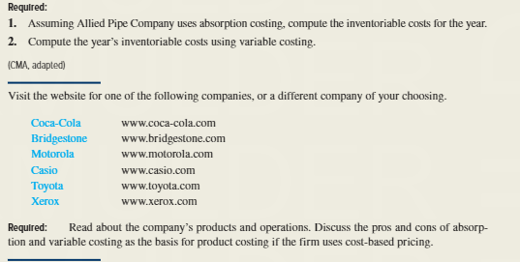
17-26
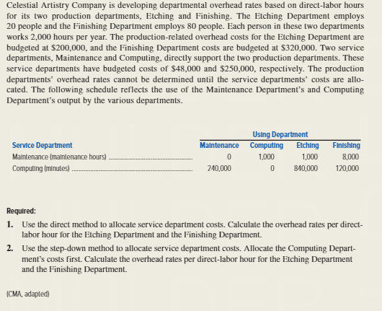

Textbook
Hilton, R. W. (2016). Managerial accounting: Creating value in a dynamic business environment (11th ed.). New York, NY: McGraw-Hill/Irwin. http://www.gcumedia.com/digital-resources/mcgraw-hill/2016/managerial-accounting_creating-value-in-a-dynamic-business-environment_ebook_11e.php

